35.58: As found in Problem (35.51), the radius of the 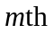 bright ring is in general:
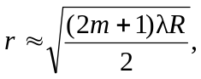
for 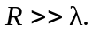 Introducing a liquid between the lens and the plate just changes the wavelength from 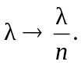
So:
